GomSpace TSP solar panel definition

# Table of Contents

1 Table of Contents 2

2 Introduction 2

2.1 Configurable Solar Panel Requirement 2

2.2 Input from Rasmus 3

2.3 Mechanical details 3

2.4 Electrical details 4

2.4.1 Basis for the design & Considerations for changes 4

2.4.2 Limits: Serial and parallel configuration 4

3 Appendix, Solar panels 7

3.1 Azur Space 7

3.2 Cesi Solar panels 7

# Introduction

This document describes the considerations for definition of TSP panels with regards to P60 and P80 configured satellite systems. Most of the document is trying to figure out the possibilities gives by the P60 and P80 systems and the possibilities this TSP panels are providing.

The document is only describing the 6U panels. (3 panels * 2)

During the document definitions for both Cesi and Azur space solar cells are used. They have some similarities and some differences.

## Configurable Solar Panel Requirement

* The overall requirements are to design each panel with 15 solar cells.
* These cells shall be connected in 2 max 3 strings.
* The designed panels may be able to be used in all positions 1 to 3 (4).
* It is needed to be able to measure the temperature on minimum 1 panel on each side of the satellite.
* It is highly wanted to be able to use either Cesi cells or Azur cells on the same design (not combined but either or)
* Temperature range -75 to +105⁰C
* Electrical:
  + Blocking Diode (to be Considered), needed if more strings in parallel on same ACU channel.

## Input from project lead and mechanics

Temperature to be expected, solar panels are exposed to extreme temperature cycling during flight:

In sun: +80 - +90 ⁰C. In Eclipse: -75 ⁰C. Pearls was tested with 22K temperature cycles, cycling from -75 to +105 ⁰C. Other components on the solar panel PCB should be able to operate in the same temperature range, as the thermal inertia in the solar panel PCB is relatively small.

The suggestion is to replace the traditional electric connection of solar cells, from existing soldering to Welding. Use of welding should be easier to control in term of heat, but it requires

* Design for welding; no components at the backside of the PCB (in the area where welding shall be supported)
* Other PCB surface treatment (e.g. ENEPIG, compared to today=ENIG)

PCB type:

It is suggested to use Arlon NT, as this has the lowest variation over temperature, compared to Arlon 85. To investigate how are the CU traces stressed when used with Arlon NT in the extreme solar panel temp range.

Connector/Cable type:

AXON connector like Pearls (TSP-8UL), cables will then be manufactured by “amgab.se”.

Earlier we used Pico-lock

RELEASE MECHANISM:

Release of the solar panels consider reuse of the concept from “Reflect array”. This is an interstage that only provide burning and release detection feature no further functionality is supported by this design. Check the AR6 board, and

GitHub\hw_family_nanopower\TSP-8UL-Pack\Panel-Release-Mechanism\Release_Main

Ensure redundancy for the release PCB design.   
Today there are 2 uC and each of the uC controls 2 release resistors, 1 in each side of the release PCB. Additional the burn power goes to a connector.

Check how the burning is done, which wire runs across which resistor?

To where (from the connector) does the burn power go?

## Mechanical details

The mechanical design is made in way where the same PCB can be used on all places in the solar array.is decided to be made with as much reuse as possible. In principle is all panels in a wing are equal, no matter if it is placed nearest the structure or any other places.

The requirement is that the constructed panel are made by combining 3 panels, repeated on both sides of the structure. These “wings” are connected mechanically to the structure by a gearbox, the gearbox makes it possible to turn the panel for maximum solar contact.

Number of solar cells pr. panel is due of mechanics limited to 15 cells total per panel. These cells are expected to be arranged into either 3 strings or only 2 strings. This will be described in the next pages.

* 6U: 15 cells.

Request are 1 to 4 panels pr. wing.

## Electrical details

### Basis for the design & Considerations for changes

The chosen solar cells are manufactured by Cesi or Azur.

Electric key data for these cells is:

Azur space Cesi .

Open circuit voltage: 2.69V 2.60V

Closed circuit voltage 2.40V 2.26V

Current (max) 504mA 510mA (Up to)

These key data will be used in the following considerations / calculations.

### Limits: Serial and parallel configuration

The connection to the battery is done via an electric circuit, this circuit has some limitations both with regards to input voltage and maximum current.

The circuit used to connect the solar panels to the batteries are called Array Condition Unit; ACU, this unit boost the received voltage from solar panels to the battery level and adjust the current drawn from the solar panels.

P60 are as follows:

* + 6 Input channels
    - Vin = maximum is equal to Vbat; limited to maximum 25 V.
    - Iin = 2A max

P80 are as follows:

* + 12 Input channels
    - Vin = maximum is equal to Vbat; limited to maximum 25 V.
    - Iin = 1.2A max

With these numbers in mind it is possible to determine the possible configurations for connection of the solar array to the ACU unit. Open circuit voltage is used and maximum current.

Calculations to identify the max. number of serial and parallel solar cell per ACU channel. When cells are connected in serial the voltage is raising with the number of cells -> this is considered when maximum numbers are calculated – When cells are connected in parallel the current is raising with the numbers off cells -> this is considered when numbers are calculated.

Max input in serial: (Vbat or 25V / Vopen circuit) = max

Max input in parallel: (Iin / Imax) = max (2A for P60 and 1.2A for P80)

Battery voltage is calculated with 4.2V pr. cell. Gives the following:

16.8V battery Azur Cesi cells

Numbers of cells in serial 6,25 -> **6** 6,45 -> **6**

Numbers of cells in parallel (P60) 3,96 -> **3** 3,92 -> **3**

Numbers of cells in parallel (P80) 2,38 -> **2** 2,35 -> **2**

25.2V battery (25Vmax) .

Numbers of cells in serial 9,29 -> **9** 9,26 -> **9**

Numbers of cells in parallel (P60) 3,96 -> **3** 3,92 -> **3**

Numbers of cells in parallel (P80) 2,38 -> **2** 2,35 -> **2**

The maximum current allowed into the ACU is maximum for the circuit, maximum for the components is higher due to the derating factor used in Gomspace designs, if this factor is adjusted it might be possible to get more cells in parallel; especial P60 is “close”.

### Thermal considerations

When connecting solar arrays to input on P60 / P80 it is crucial to consider the thermal problems also. The ACU is not 100% effective it is a good design, but the loss must be considered when configuring the system.

If the efficiency is 93% the loss is 7%. If P60 is loaded maximum; 9 cells in serial and 2 string on each power path it gives the following: 9*2.33V * 0.5 mA *3 31.455W -> 7% loss is 2.2W pr. channel = 6*2.2W = 13.2W and if the environment temperature is 90oC it gives a problem because the dissipated heat cannot or only difficult be dissipated to the environment.

**Solar Cell:**

|  |  |  |  |  |
| --- | --- | --- | --- | --- |
|  | **AZUR** | **CESI** |  |  |
| **OCV** | 2690 | 2600 | mV |  |
| **MPV** | 2409 | 2300 | mV |  |
| **I_Short** | 519.6 | 520 | mA |  |
| **I_MP** | 502.9 |  | mA |  |

Based on ACU and Cell spec. The following apply per ACU channel:

* **Parallel = 4 (P60)** (Consider thermal, 4 parallel is NOT possible for all channels at same time)
* **Parallel = 2 (P80)** (Consider thermal, 2 parallel is NOT possible for all channels at same time)
* **Serial = 6** [16V battery]
* **Serial = 10** [32V battery – limited by 25V input]

11 [32V battery – 11 solar cells can be used, but efficiency drops. See details below]

Parallel limits:

* Given by the max. current to ACU = 2A. And the Max Power Point current from the Solar cell = 0.5A
* The power dissipation/heating, means that it is NOT possible to have 2A at each channel. The current per active channel should be distributed evenly across all ACU channels. Consider also if the mechanical design means that some cells are placed opposite on the satellite (e.g. eclipse side vs. sun side
* P60: for P60 the charge current is limited by the P60 dock, which accept max. 4A charge current
* P80: for P80 the charge current is limited by the BP8 battery pack and ACU. BP8 accept max. 4A charge current per Battery pack

Serial Limits:

* Given by 2 factors:
  + Solar cell OCV, too high voltage can damage the ACU electronics. It is hard requirement to stay below.
  + Solar cell OCV should be lower than VBAT=4V/Battery cell
    - **16V Battery + Azur:** 16.8V/2.69V= 6.25 cells
      * (**6 cells** = Max)
    - **16V Battery + Cesi:** 16.8V/2.6V=6.46 cells
      * (**6 cells**= Max)
    - **32V Battery + Azur:** 33.6V/2.69V=12.49 cells
      * (**12 cells** =Max)
    - **32V Battery + Cesi:** 33.6V/2.6V=12.92 cells
      * (**12 cells** =Max)
  + Solar cell MPV, gives how efficient the cells can be used. Voltage level exceeding this limit will be wasted, as the ACU will adjust down to 25V.
  + Solar cell MPV should be lower than 25V to ensure good efficiency, as it is efficiency/during operation it is the MPV is the solar cell voltage to consider.   
    I.e. Voltage, from Solar cell, above 25V will be “wasted”.
    - **32V Battery + Azur:** 25V/2.409V=10.378 cells
      * **10 cells** (Full Efficiency from all 10 cells)
      * 11 cells (Efficiency = 38% of the 11’th cell)
    - **32V Battery + Cesi**: 25V/2.3V=10.870 cells
      * **10 cells** (Full Efficiency from all 10 cells)
      * **11 cells** (Efficiency = 87% of the 11’th cell)

# Appendix, Solar panels

There are 2 types of solar panels on stock, Azur and Cesi. Electrical connection is different between Azur and Cesi solar panels (Anode and Catode is placed different) It might be possible to design a footprint for PCB covering both Azur and Cesi cell types even the cathode and Anode is placed different. If this is possible and are used it will make the designes solar panel more flexible for future use.

## Azur Space

Azur solar panel P/N: 3G30A W and W/O diode

Most effective and most costly.

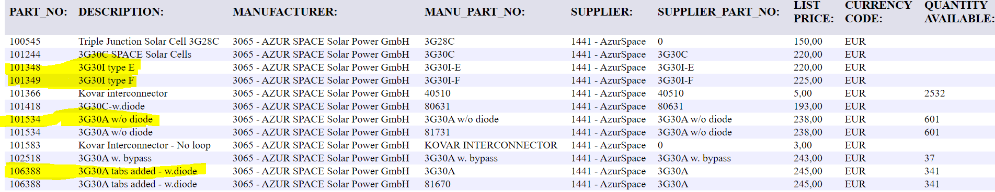

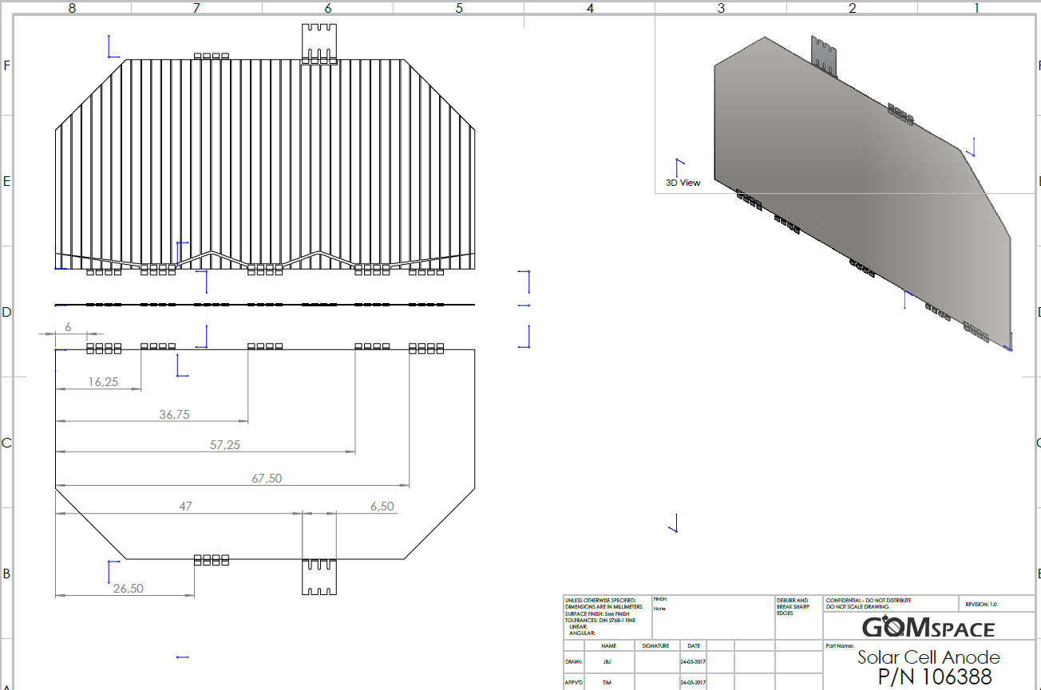

## Cesi Solar panels

CESI solar panel P/N: CTJ/SCA-8040/GOM

Less effective compared to Azur, but “Cheaper” than Azur.

Very high quantity on stock (3523 pcs.)



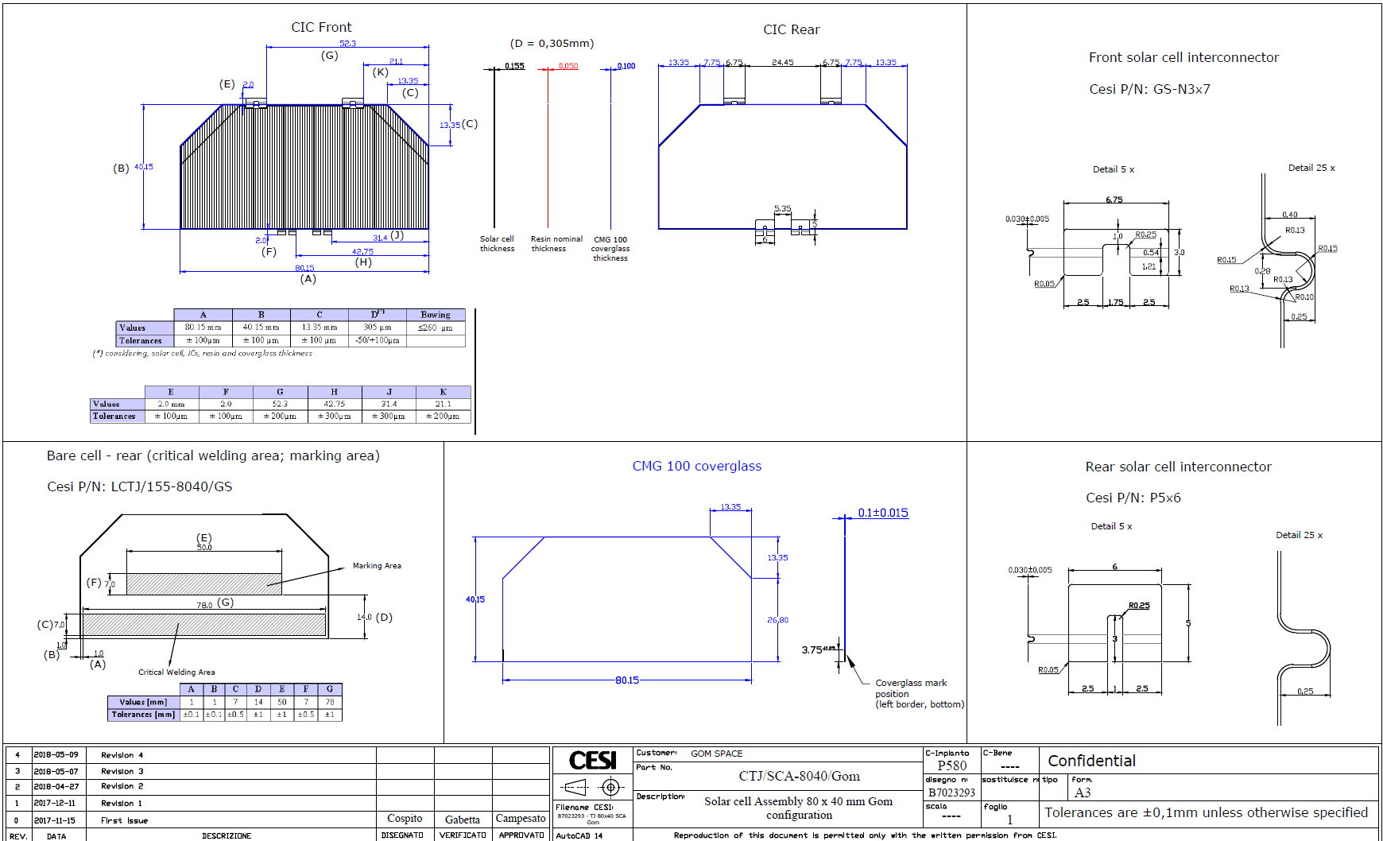

**<End of document>**